# Setting up Tinkercad

* Sign up for a user account on Tinkercad:

<https://www.tinkercad.com/join>

* Once you log into the website, click on **circuits** on the left-hand side:

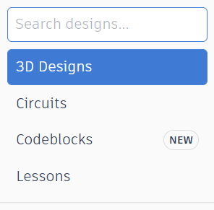

* Then **Create New Circuits** in the middle:

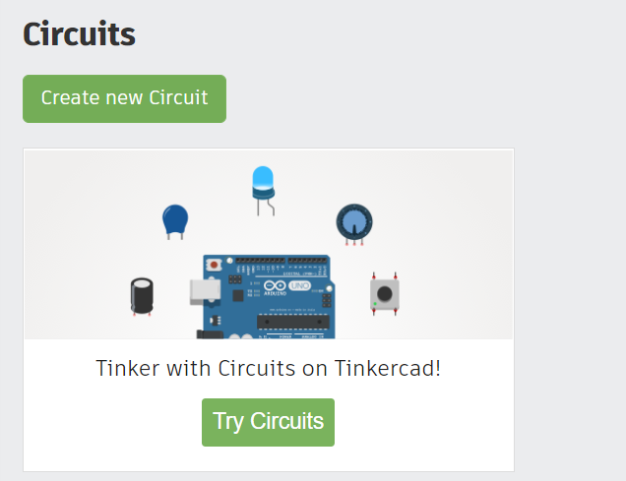

* In the top-right corner, click on **Arduino** and select the simple **Blink** circuit:

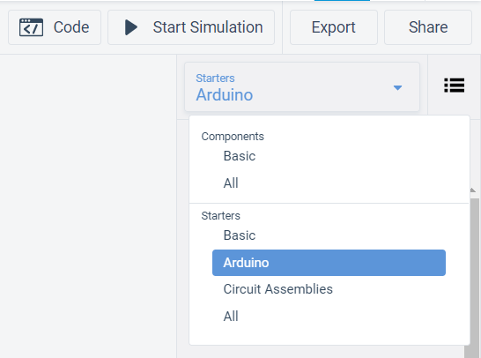

* Drag the **Blink** circuit into the middle of the screen and then click on **Start Simulate.** Your workspace should look like the one in the following screenshot and both the external LED and the LED on the board should start blinking.

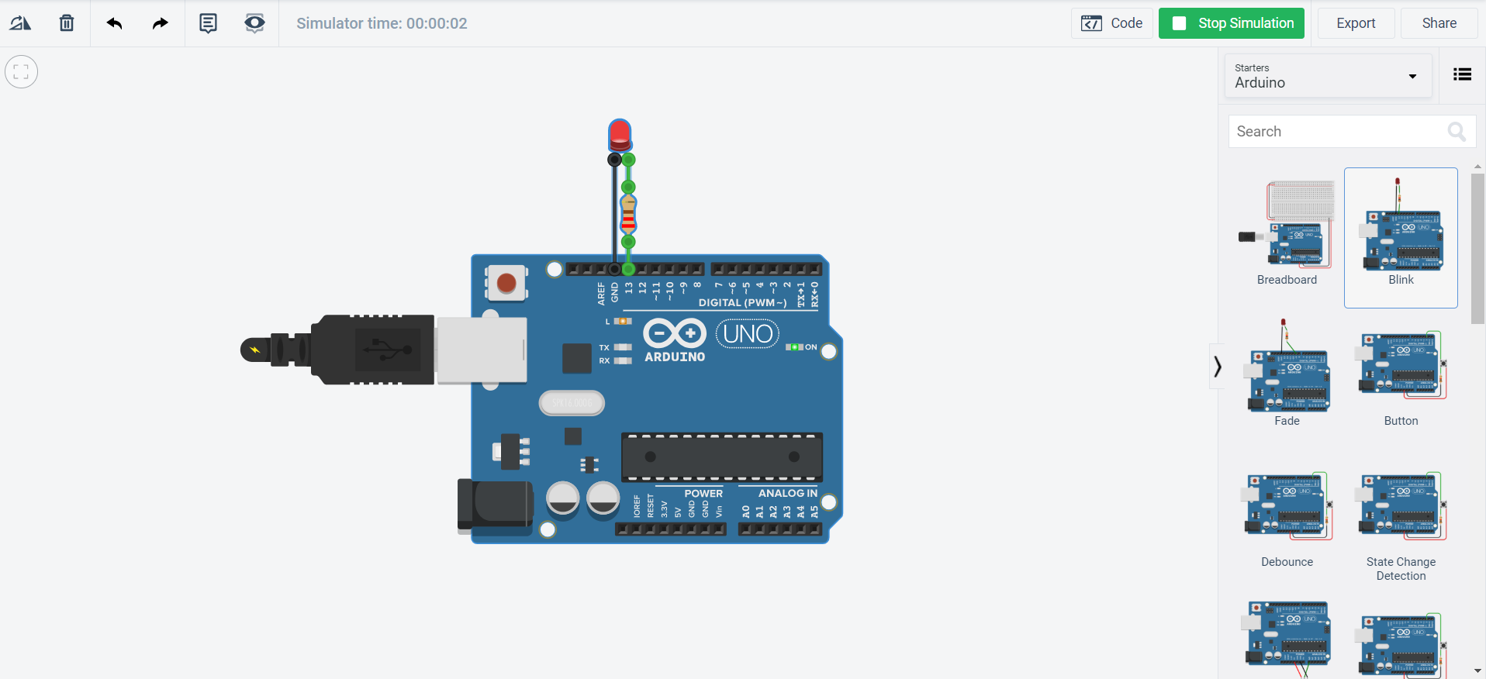

**That’s it! You are now setup to use Tinkercad.**